JAVA PROGRAM 2D ARRAY.

1) import java.util.Scanner;

public class Main{

public int linearSearch( int[] arr,int n,int key)

{

for(int i=0;i<arr.length;i++){

if(arr[i]==key){

return i;

}

}

return -1;

}

public static void main(String[] args) {

Main m=new Main();

int n;

int key=50;

Scanner sc=new Scanner(System.in);

System.out.println("Enter the number of elements:");

n=sc.nextInt();

int a[]=new int[n];

System.out.println("Enter elements");

for(int i=0;i<n;i++)

{

a[i]=sc.nextInt();

}

int index=m.linearSearch(a,n,key);

if(index==-1)

System.out.println("Not found");

else

System.out.println(key+"is found at index:"+index);

} ;

}

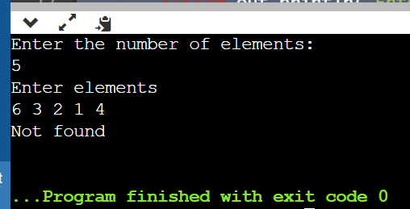

2) public class Main{

public static int linearSearch( int[] arr,int key)

{

for(int i=0;i<arr.length;i++){

if(arr[i]==key){

return i;

}

}

return -1;

}

public static void main(String[] args) {

int []a={10,20,30,50,70,90};

int key=50;

int index=linearSearch(a,key);

if(index==-1)

System.out.println("Not found");

else

System.out.println(key+"is found at index:"+index);

};

}

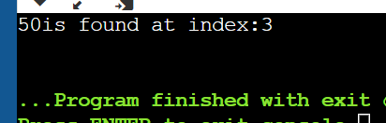

3) public class TwodimensionalLoop{

public static void main(String[] args)

{

int[][] a={{10,20},{30,40},{50,60}};

System.out.println("Two Dimensional array elements are:");

for(int i=0;i<3;i++)

{

for(int j=0;j<2;j++)

{

System.out.print(a[i][j]+" ");

}

System.out.println(); }

}

}

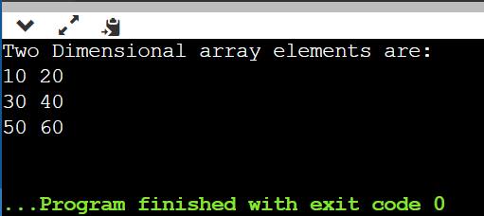

4) import java.util.Scanner;

public class TwodimensionalLoop{

public static void main(String[] args)

{

Scanner sc=new Scanner(System.in);

int[][] a=new int[4][3];

int i,j;

System.out.println("Enter array elements");

for(i=0;i<4;i++)

{

for( j=0;j<3;j++)

{

a[i][j]=sc.nextInt();

}

System.out.println("Two Dimensional array elements are:");

for( i=0;i<4;i++)

{

for( j=0;j<3;j++)

{

System.out.print(a[i][j]);

}

System.out.println(); }

}

}

}

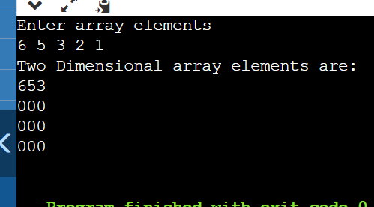

5) import java.util.Scanner;

public class TwodimensionalLoop{

public static void main(String[] args)

{

String[][] salutation={{"Mr.","Mrs.","Ms."},{"Kumar"}};

System.out.println(salutation[0][0]+" "+salutation[1][0]);

System.out.println(salutation[0][1]+" "+salutation[1][0]);

System.out.println(salutation[0][2]+" "+salutation[1][0]);

}

}

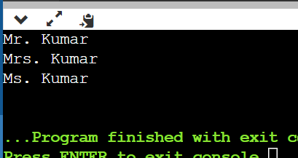

6) import java.util.Scanner;

public class TwodimensionalLoop{

public static void main(String[] args)

{

int [][] board=new int[3][3];

int i,j;

Scanner sc=new Scanner(System.in);

System.out.println("Enter array elements");

for(i=0;i<board.length;i++)

{

for(j=0;j<board[i].length;j++){

board[i][j]=sc.nextInt();

}

}

System.out.println("Array elements are:");

for(i=0;i<board.length;i++)

{

for(j=0;j<board[i].length;j++){

System.out.print(board[i][j]+" ");

}

System.out.println();

}

}

}

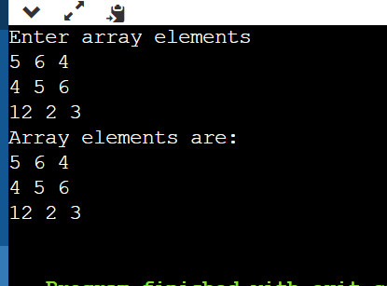

7) import java.util.\*;

public class TwodimensionalLoop{

public static void main(String[] args)

{

int [][] board=new int[3][3];

int i,j;

Scanner sc=new Scanner(System.in);

System.out.println("Enter array elements");

for(i=0;i<board.length;i++)

{

for(j=0;j<board[i].length;j++){

board[i][j]=sc.nextInt();

}

}

System.out.println(Arrays.deepToString(board));

}

}

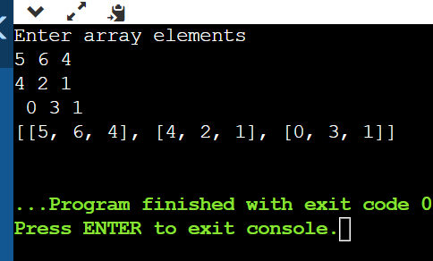

8) public class TwodimensionalLoop{

public static void main(String[] args)

{

int [] board={1,2,3,4,5};

int i,j,sum=0;

double avg;

System.out.println("Enter array elements");

for(i=0;i<board.length;i++)

{

sum+=board[i];

}

avg=sum/board.length;

System.out.println("Sum is"+sum);

System.out.println("Avg is"+avg);

}

}

